Production of digital watches by 3D printing +

Measuring load intensity in Physical Education classes using a smart watch

Ratíškovice primary school and nursery school
Vítězná 701, 69602, Ratíškovice, Hodonín district

Contents:
1. Project information 3
1.1. Project objectives 3
1.2. Age group involved in the project 3
1.3. Key skills required for project implementation 3
2. Material equipment needed for the implementation of the project 4
2.1. Device 4
2.2. Parts and consumables 4
3. Financial calculation of the project 6
4. 3D printing 7
5. Programming with Micro:bits in the Makecode environment 10
6. Assembly of the digital clock structure 21
7. Assembly of the structure for the optical gate 25
8. Heart rate measurement using a smart watch 27
8.1. A bit of theory 27
8.1.1. Heart beat 27
8.1.2. Heart rate zones 27
8.2. Statistics 28
8.3. Heart beat 29
8.4. Heart rate zones 30
8.5. Active calories 34
8.6. Evaluation 34
9. Conclusion 37
10. List of links 41

Project information

Project objectives

As part of the project, digital stopwatches will be created to measure time in physical education classes. Stopwatches will mainly be used to measure endurance disciplines. The results will be saved. Subsequently, the hours can be used in the analysis of the annual fitness improvement of the students.
Students will learn about 3D printing. The structural part of the digital clock will be created using a 3D printer.
Students will also get to know the MicroBit microcontroller and learn to use its development environment. A connection will be created with a digital Led strip, which will be used as a basic building element. The device will be expanded with a user interface and an optical gateway.
A partial goal of the project will be to record the intensity of physical education classes for a selected group of students using smart watches. Using data collection through regular measurements and evaluations, also obtain information about the condition of these pupils and then try to increase the intensity of the lessons and the performance of the students.

Age group involved in the project

3D printing and working with smart watches with subsequent statistics could be mastered by seventh graders. However, since the programming of the digital clock itself is part of the project, which is quite demanding, the project could be implemented by students in the last years of elementary school, but also at a specialized high school.
Ten pupils worked on our project, four of them from the ninth grade and six from the seventh grade.

Key skills required for project implementation

- General knowledge of working with computers
- Awareness of working with smart watches and basic health statistics
- Programming with a Microbit microcontroller
- Basics of 3D printing and a program for 3D modeling
- Basics of working with tools and electrical components

Material equipment needed for the implementation of the project

2.1. Device

- 3d Printer
- Melt gun
- Soldering station
- Smart watch

2.2. Parts and consumables

- PLA filament transparent
https://www.czc.cz/filament-pm-tiskova-struna-filament-pla-1-75mm-1kg-transparentni/242146/produkt (Filament PM printing string (filament), PLA, 1.75mm, | CZC.cz)

- Filament PLA silver
https://www.prusa3d.com/cs/produkt/3d-tiskarna-original-prusa-i3-mk3s-3/
- BBC Micro:bit V2.2
https://www.hwkitchen.cz/bbc-microbit-v2-2-mikropocitac-pro-vyuku-programovani/

- Intelligent RGB LED strip 5m WS2812
https://pajenicko.cz/inteligentni-rgb-led-pasek-5m-ws2812-neopixel-60led-m-18w-m?search=Inteligentn%C3%AD%20RGB%20LED%20p%C3%A1sek%205m%20WS2812
Electronics tool kit
https://www.gme.cz/sada-naradi-pro-elektroniky-proskit-1pk-612nb
- Power supply + flexo cord
https://www.t-led.cz/p/led-zdroj-5v-75w-vnitrni-55013
https://www.t-led.cz/p/flexo-snura-3-metry-3x1-mm2-11123
- BBC Micro:bit smart home kit
https://www.hwkitchen.cz/bbc-microbit-kutilsky-kit/

- BBC Micro:bit starter kit
https://www.hwkitchen.cz/bbc-microbit-starter-kit/

- BBC micro:bit kit for smart home
https://www.hwkitchen.cz/bbc-microbit-kit-pro-chytrou-domacnost/
- Laser module
https://www.hwkitchen.cz/octopus-3v-laserovy-modul/

- Light sensor GL5516
- https://www.hwkitchen.cz/fotorezistor-gl5516-svetelne-cidlo/

Financial calculation of the project

Device:
3D printer - 27000,- CZK
Soldering station - 1300,- CZK
Smart watches 15 pcs - 42000,- CZK
Grinder - 1800,- CZK

Components and Material:
Micro:bit 10 pcs - 5000,- CZK
Filament 5 pcs - 3000,- CZK
RGB LED strip - 1050,- CZK
LED strip 5 pcs - 3050,- CZK
Tools 1,500, - CZK
Power supply 1 pc + flexo cord - 600,- CZK
Micro:bit set 10 pcs - 12900,- CZK
Tin solder 210,- CZK
Laser 3 pcs - 270,- CZK
Photoresistor 2 pcs - 20,- CZK
Total: 99700,- CZK
However, not everything was needed for the project itself. For example, only a minimum of the micro:bit sets was used. Thanks to the increase of the informatics hours within the framework of the educational project, these items will definitely find their justification in our school.

3D printing

Since our school did not own a 3D printer until now, and the students involved in the project only worked with it at the Workshop on 3D printing where they learned selected programs as well, we decided to use www.thingiverse.com to help with the design of the clock.

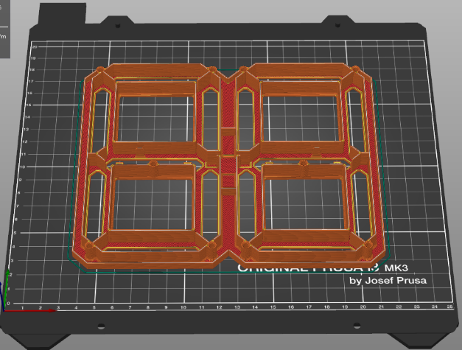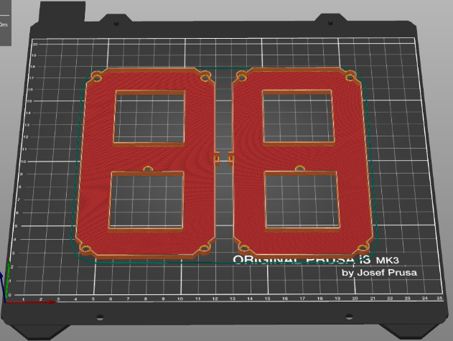
Front and back of the clock. Each had to be printed twice. One for the second part and one for the minute part.

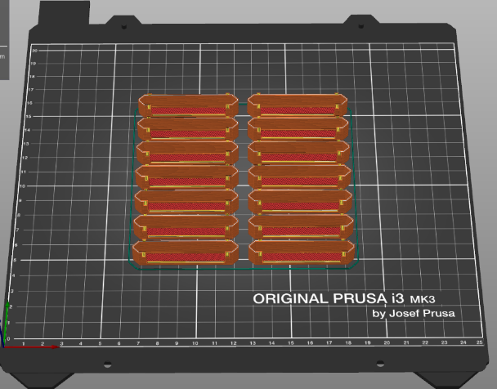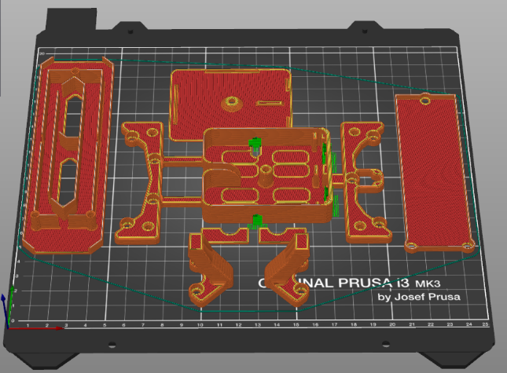
The image on the left shows individual displays that were printed using transparent filament. The picture on the right shows the legs for better stabilization of the clock, the middle part of the clock and the box for storing the controls. Since we control the stopwatch with a microbit and it does not fit into it together with the flat joint, the box is only used to connect the individual parts of the clock.
However, what needed to be realized fully under the auspices of the students was the design and subsequent 3D printing of two pads for attaching the optical gate (one for the laser and one for the photoresistor). Here, each of the pupils, based on the assignment, tried to design their mats in the Tinkercad online program. We selected the best mats and then prepared them for printing using the PrusaSlicer program and then printed them.
During the testing of the optical gate at the very end of the project, a problem arose with the fact that the photoresistor did not react favorably to the laser in classic daylight, or to the interruption of the laser beam flow – the device did not do what it was supposed to. For that reason, we proceeded to 3D print a simple tube that serves as the outlet of the photoresistor. It is necessary to think about this problem when manufacturing an identical or similar device.

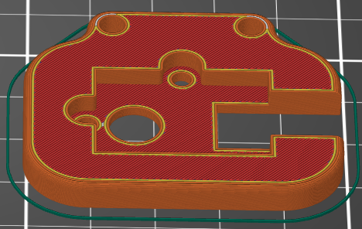
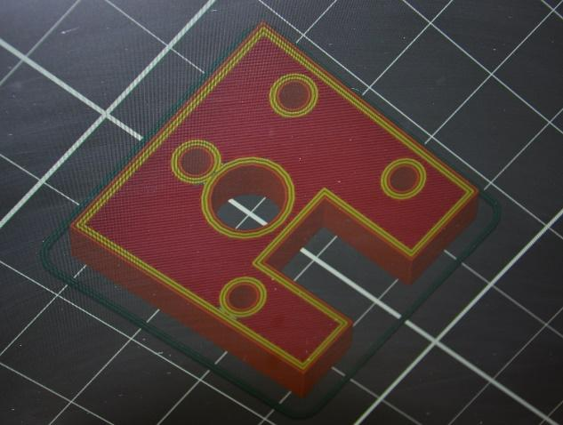
Pad designs for the sensor. One of the first designs is on the left. The final draft is on the right.

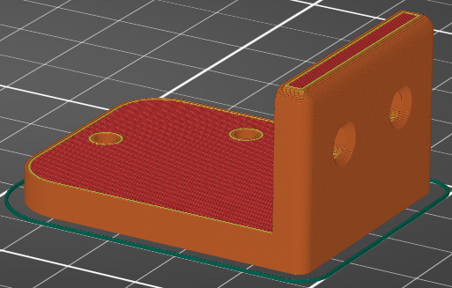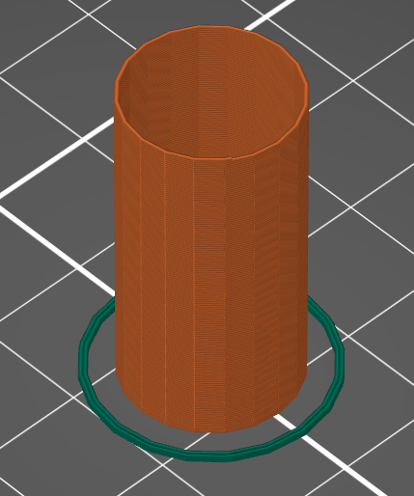
The final design of the base for the laser Tube for the mouth of the photoresistor

The most common errors and possible problems:
In the PrusaSlicer program, it is important (as with any 3D printing) to set up the printing itself. The height of the layer and the setting of the filling are a matter of course, but the students had fun with setting the supports. We basically left them to figure it all out on their own. It cost us a little extra filament, but the students at least automated their work with the program in the meantime.
At the beginning of printing (applying the base layer), you need to pay attention to fine-tuning the Z axis. The first attempts to design our clocks were not always successful.
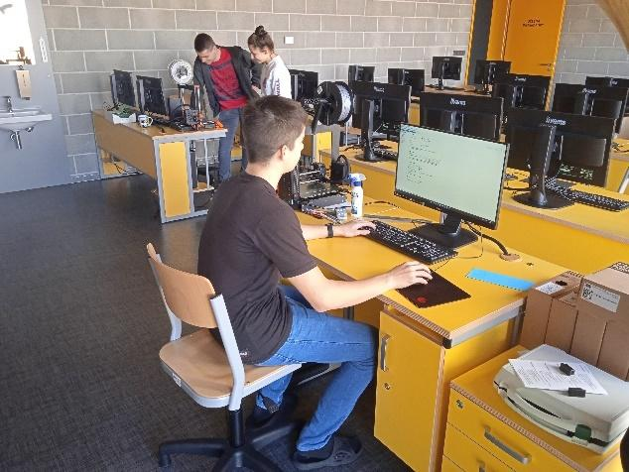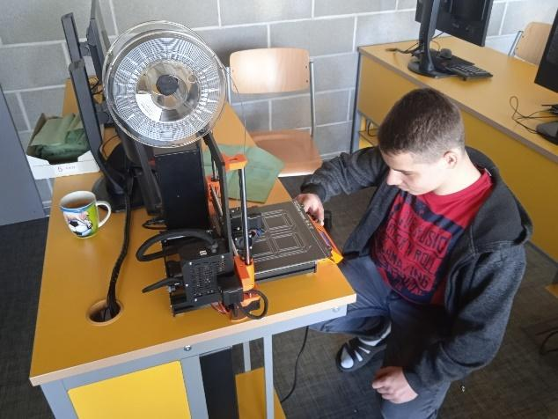
In Tinkercad, as with all drawing programs, you need to be consistent and check the accuracy of execution. There are different ways to log into the program, either through a created class or through personal accounts. We chose the option via personal accounts (the students already worked on them during the Workshop). A google account is required for this.

Programming with Micro:bits in the Makecode environment

All programming using the microcontroller visual programming environment was done at www.makecode.microbit.org. It is a simple editor where programming is done using blocks. When you open the page, you will notice at first glance that the program is in Czech (of course you can switch to English). After entering a new project, every programmer finds himself in the programming environment. It's fair to say that even such a simple program was initially a challenge for our students, because the teaching of informatics at our school ended in the sixth grade and everyone saw the programming environment and the entire microbit for the first time. Programming was certainly the most time-consuming part of the entire project.

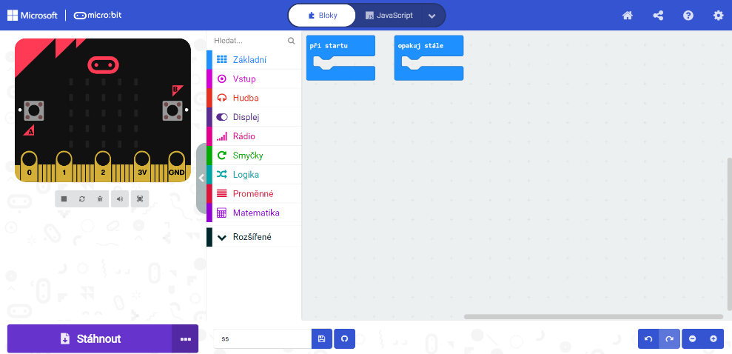

When we find ourselves in the programming environment, we can't fail to notice the image of the microbit (where we can simulate the entered steps), the tabs with the program's functions, the field itself for inserting blocks and, last but not least, the download button, with which we send everything programmed directly to the microbit connected to the computer using usb cable.
Among the basic functions, the necessary extension for programming the Led tape is missing for us. Using the Advanced menu, you can search for the Neopixel library you need and add it to the standard equipment of the program.
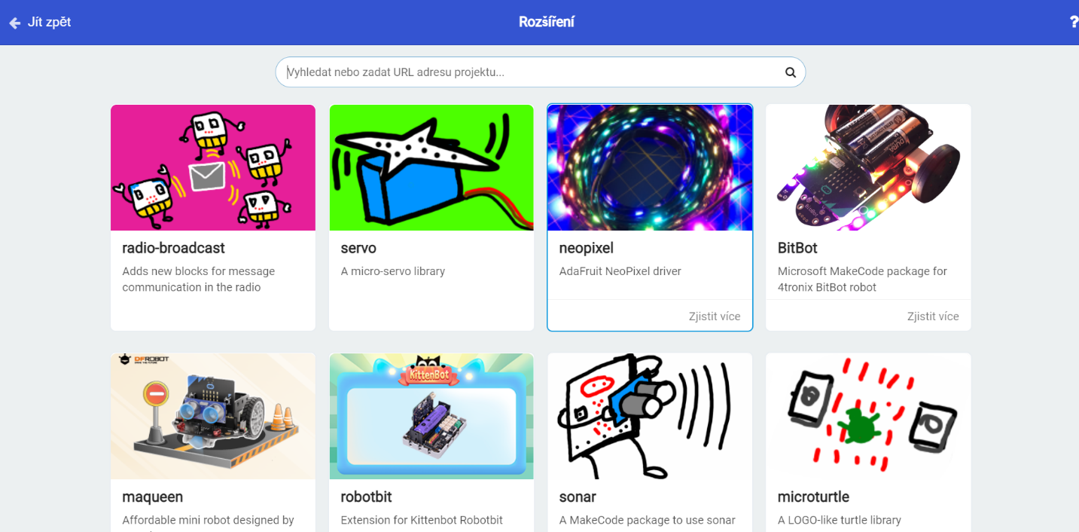

Programming the digital clock:
At the very start, we had to choose what kind of clocks we were going to create. Clocks designed more for the endurance profile of the track were offered – field of minutes and field of seconds. The second variant corresponded more to the speed disciplines – field of seconds and field of hundredths. After all possible pros and cons, the first endurance option was chosen. It suited the teachers more in terms of fulfilling the project's goals. Another factor is the generally more neglected condition of pupils these days and the associated possible tests of movement skills. Another factor that needs to be taken into account are the outdoor spaces of our school intended for physical education, where there is no track for sprint disciplines, on the contrary, cross-country running can be practiced almost everywhere. Last but not least, technical possibilities need to be taken into account. We weren't sure how the optical gate would work for multiple splits in quick succession (sprint), which is easier to eliminate in an endurance event, and also if there were hundredths in the imaging capabilities of this type of device.
Start of the program:
During programming, we first had to set two basic blocks – at start and repeat all the time. The block at startup is executed only once, when the device itself starts up. This means that when the clock is turned on, the first thing that happens is that the segment is set – the LED strip is broken into individual numbers (the parts from which the numbers will be formed). Two segments are set because we have two parts of the clock: minute and second. Furthermore, when the device starts, variables are created – half-minutes and half-seconds, which will be needed to create intermediate times. The variables will be set to an empty list, in which the split times will then be stored. In order for everything to match, an intermediate time counter is also needed, which, as the name itself suggests, is used to verify the number of intermediate times. Setting end to 0 is used to stop the entire program. The last function that happens at the start of the program is the setting of the variable strip 3, which is the middle part of the clock, which will be constantly lit for the entire duration of the program.

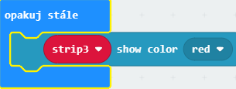
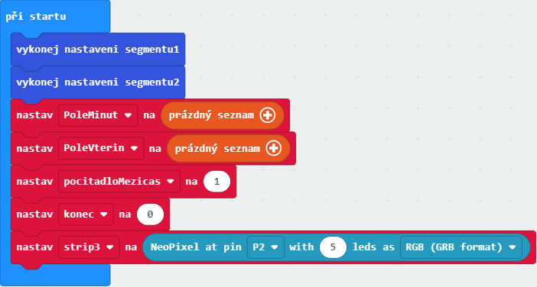

Our procedure:
For easier understanding, we prefer to describe how we proceeded during creation. There are certainly more variations, but due to constant testing and bugs in the program, we tried the following. As already written above, the function at the start remained unchanged for the entire time since the setting. The rest underwent significant changes more or less all the time. The repeat function is still different from the picture above, and only one function – the constant lighting of strip 3 (the colon between the minutes and seconds field) has only grown with a laser at the very end. It will be explained below. The display functions remained more or less unchanged after the original settings, the program underwent the biggest changes when working with the microbit buttons. All will be described separately, but while button A started the clock from the very beginning, button B first simulated the function of the laser, which was programmed only at the end when verifying the correctness of the intermediate times using the buttons. In the beginning, simultaneous pressing of buttons A and B was also used to end the program and call up intermediate times. After applying the laser, everything shifted – the laser was assigned to the repeat block, Button B began to be used to end the program, and pressing buttons A and B at the same time stopped working and had no effect on the clock.

The image below clearly shows the simulation of the program when using the buttons (A, B and A+B) without connecting the laser, with the central part of the clock constantly lit.
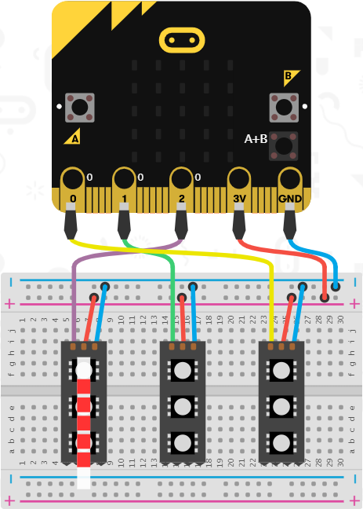

Button A:
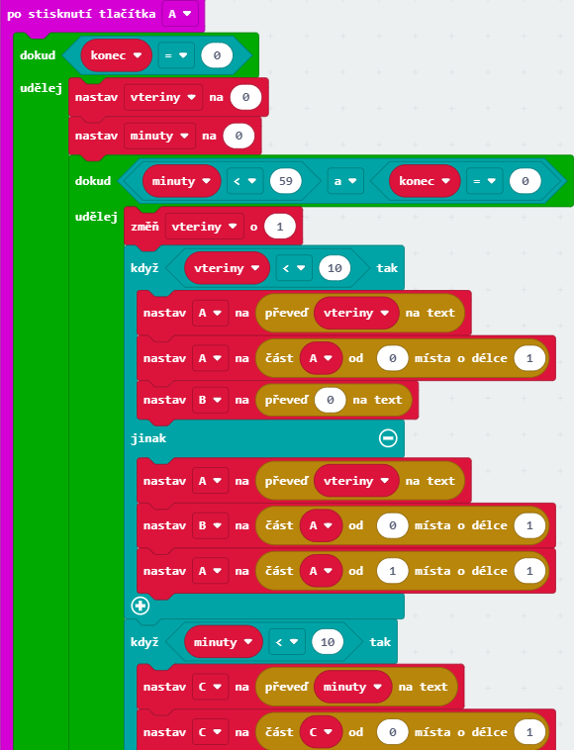
Pressing the A button will start a set loop where the clock will keep adding values ​​until the end is 0. The first thing that will happen is that the seconds and minutes will be set to 0. The next loop will increase the seconds in a second interval up to the value 59. In order to be able to display all this, everything is divided into four parts, since the seconds and minutes have two segments on the clock. In our case, A and B are seconds (1st and 2nd numbers) and C and D are minutes (1st and 2nd numbers). In order to work with all of this, the seconds still need to be converted to text. The program then works with the text, which has two places, where it sets the variable B to the first place and the variable A to the second place. It's the same with minutes, only variables C and D are worked with. Two more similar conditions are added due to poor display during initial attempts. The first is that if the seconds are less than 10, then the number will be displayed only on one second segment, and in the second segment, 0 will be written to the power, so that only units are displayed correctly, and tens will be displayed when needed. It is basically the same with minutes (the second condition). The last issue that needed to be resolved was that our seconds at the end of each minute jumped to zero, effectively shortening each minute by a second. In order to eliminate the defect, a condition is inserted into the program, in which it is set that if the seconds are equal to the value 59, then another minute is added and the seconds are reset to zero.
All the display is adapted to split the individual numbers for us, when for example the number 15 is split into 1 and 5. Everything is automatically sent to the display functions, thanks to which whole numbers are shown. The way the display functions work is that when any part of the display (A, B, C, D) equals 0, it displays 0. If A equals 1, it displays 1, and so on.
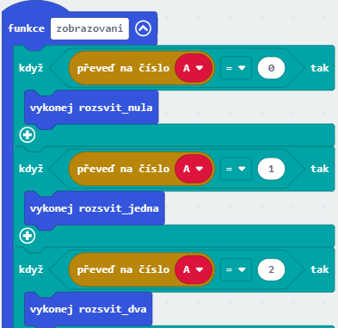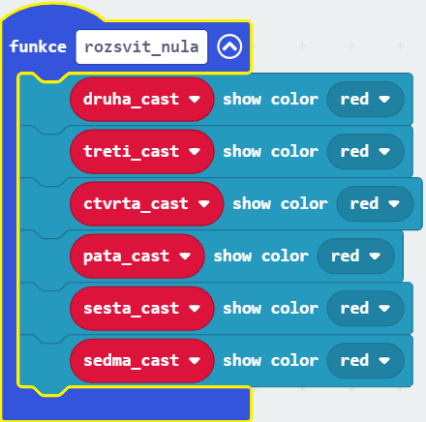

B button (before laser insertion)
When creating the program, we also used the B button. At first, the B button was used to create intervals when pressed, and this button thus simulated the function of an optical gate. In the resulting form, everything related to split times was performed by the laser. The principle is the same as for the A button. We will convert the minutes and seconds fields to text so that the split time can be written into the list and it will be inserted at the end. In that case, the split time counter will change by one and the user will have an overview of their number.
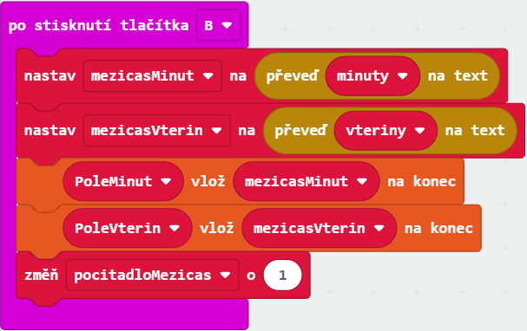
After we figured out how to work with split times, we proceeded to program the optical gate.
Keep repeating after inserting the laser (final version)

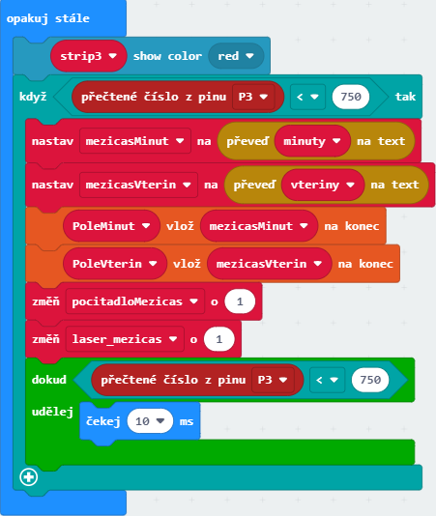
Compared to the beginning, when the repeat block still lit up only the middle part of the clock, its appearance changed very significantly when the laser was introduced. Everything previously done with the B button is assigned to this block with one condition, added laser and one extra loop. If the number read from pin 3, on which the sensor is connected, is less than the number 750, and the laser flow to the sensor is interrupted, an intermediate time will occur. The display principle is the same as when using the B button before introducing the laser - we convert the minutes and seconds field to text so that the split time can be written into the list and inserted at the end. In that case, the split time counter will change by one and the user will have an overview of their number.

Additionally, one more loop is added. This is in the program because if there is an interruption of the lighting of the laser on the sensor (e.g. due to an overrun), it is prevented that more than one intermediate time is created. This is achieved by inserting a 10ms wait time into the program.
B button after laser insertion (final version)

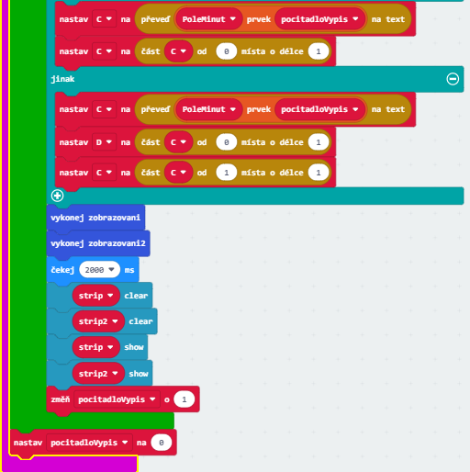
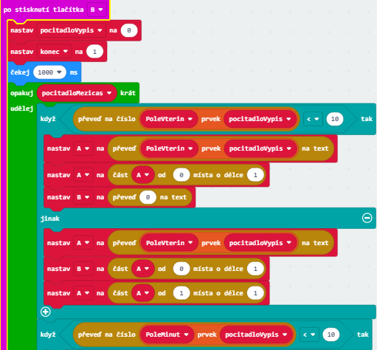
We only added the final version, when the simultaneous pressing of buttons A and B was no longer used and everything was replaced by button B (after connecting the laser). Pressing the B button will stop the program by setting the end to 1. When the split times are displayed, the clock will wait for 1 second and then the counter will be set to 0 and the whole loop displaying the split times will be repeated as many times as the split times have been recorded. For the display itself, the principle is the same as for the display of the time itself, i.e. again with the help of two conditions, when the value 10 is written in the segment for tens to the power of 0. This again happens both in the second part and in the minute part.

The most common mistakes and possible problems:
It is clear from the description of the program that it is not a simple matter and the creation of the program part of the lessons is quite time-consuming. It requires patience after countless failed attempts to get the clock running correctly. We believe that it is impossible for a student or group of students to create a program without advanced programming knowledge in the makecode environment. The procedure that worked well for us was that the teachers came up with the more difficult part and retrained the pupils in retrospect. The students tried to figure out the simpler tasks themselves, and only at this moment did the teachers become spectators, albeit (and this must be admitted) very involved.
During the programming of the clock using the LED strip, each of us will surely sooner or later come across the possibility of setting the color of individual segments in the extended Neopixel functions. While this may seem like a trivial problem, it is not the case with the work of two people, let alone a group project. There are ten color options in the basic menu and this makes a very high number of possible combinations. In the end, after a passionate debate, only one color (red) was chosen, so that our clocks wouldn't flash like carousels.
Although it may not seem like it, we had a big problem with flipping the seconds to the next minute. Below are four nearly identical images, only one of which is correct. In the first picture, after the value of 59, it immediately jumped to 01 in the second part – so every minute would be one second shorter. As you can see from the second image, we thought we would fix it by inserting a second pause after the value of 59 and solve everything. This was not the case, although the clock did not shorten the time, but after a value of 59 it went out for a second and then continued. In picture number three is another example, this time almost correct. The clock didn't go off and showed exactly, but after the value of 59, the value continued to 60 and then 01. It was probably possible to work with it, but it still wasn't the same after such hard work. Until the picture on the far right is correct, when it was only enough (perhaps a little illogically) to set the seconds to -1 if the seconds will be equal to 59. Up until now, everything has worked for us as it should. A trifle, but it cost us a lot of nerves and a lot of complications when creating the program.

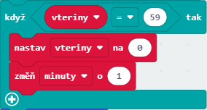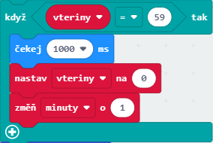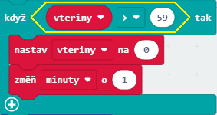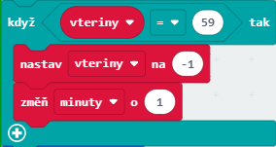
When setting the second and minute parts, it is necessary to pay attention to the correct routing of the tape inside the clock and, with it, to program the parts of the Led tape into 14 segments for each of these two parts of the clock. It is also necessary to calculate in advance how much (and which part) of the tape will be visible across the individual displays. In the picture below, there is an example of displaying diodes on the LED tape for the minute part of the clock.

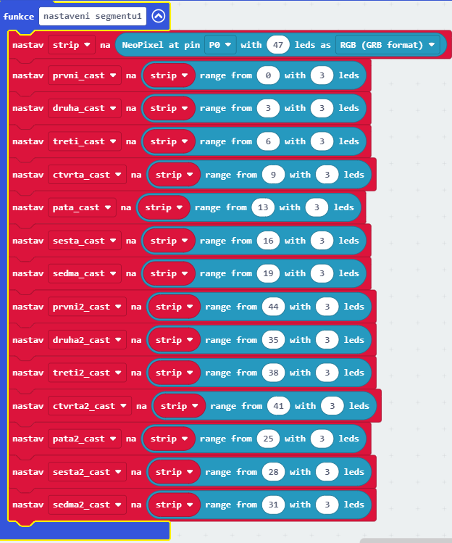

Another possible problem, especially for orientation within the program, is the large number of display functions. We have defined everything in the program extension – in the functions. In the picture below, you can see that everything can be very confusing. The function is set not only for the display of parts of the LED strip (see above), but also the function of displaying digits and the logical conditions resulting from them, and last but not least, the function of lighting up individual digits. These functions are there four times for each number, which gives a total of forty.
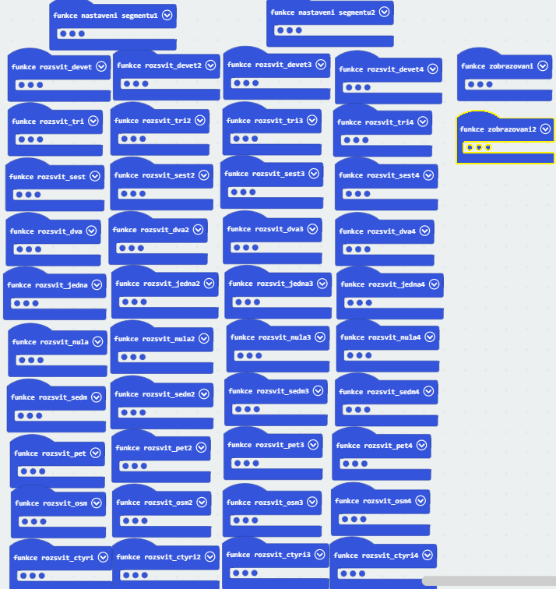
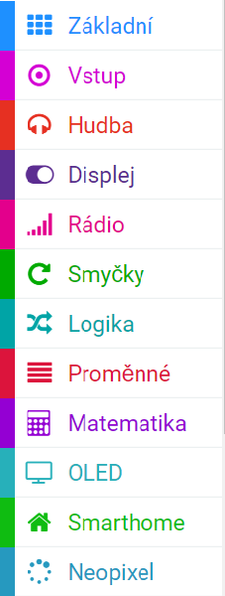
Since we were the first to test the very principle of displaying split times, we programmed the laser until the end. It follows that the B button had a different function in the first variants of the clock. It is certainly possible to deal with it in other ways, but we worked with this version.
One more insight emerges from the paragraph above. To program the laser, we had to download the Smarthome library in the program extension. It turned out that the Neopixel library was loaded with it, so we didn't have to download it separately. It's basically minimal extra work, but it's useful to know.

Assembly of the digital clock structure

After printing and programming, it was time to assemble the individual parts and components to make the clock complete. During the work, the pupils worked in a team and strengthened mutual cooperation. A melt gun was used to anchor the printed transparent filament segments to the front of the clock (these transparent segments were first slightly sanded with a sander for easier attachment). Last but not least, screws were used to connect the front and back parts of the clock, as well as the minute, middle and second parts of the clock.

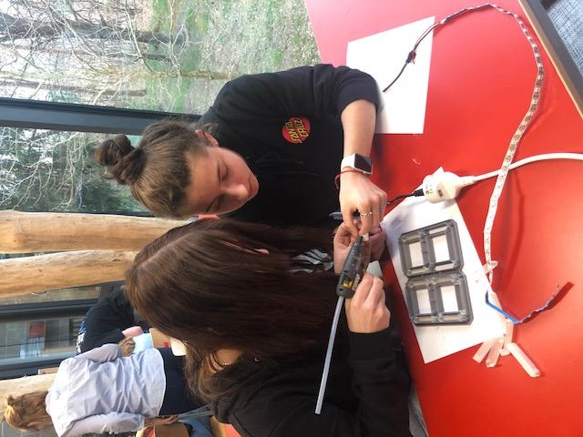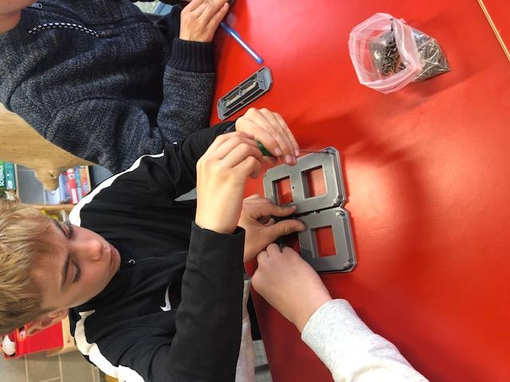

Wiring:
A soldering contact field is used to connect the clock, microbit, power supply and optical gate. Individual connecting wires and remaining wires were gradually soldered to this printed circuit board. To connect the optical gateway, we used a UTP cable, which we cut and connected to the laser and the sensor at one end and soldered to the soldering iron at the other end. An expansion module for the contact field is also attached to the printed circuit board, into which the microbit that controls the entire device is inserted. Last but not least, the power supply is connected to the soldering contact field.
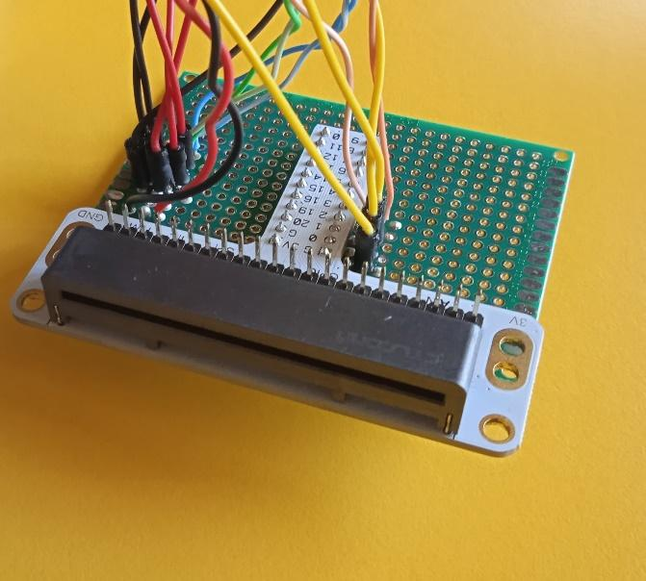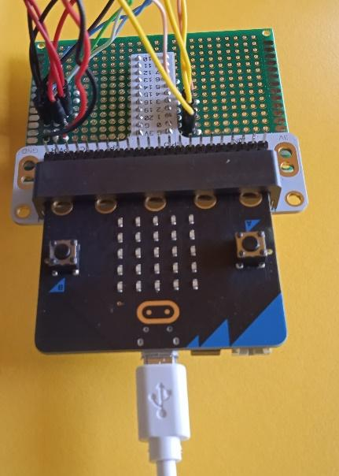
Soldering contact area without and with microbit
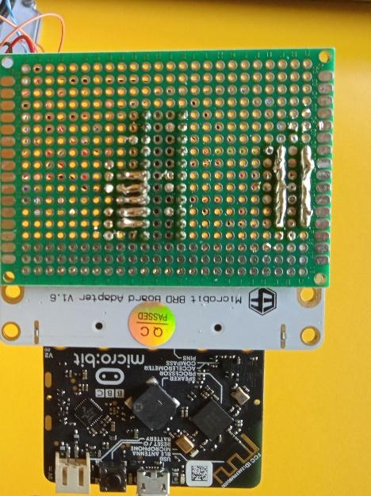
Back view of the PCB
The most common errors and possible problems:
We decided to glue the displays using a hot melt gun, which results in problems with (in)sufficient amount of glued material and good stabilization of the displays. After the first gluing, half of them fell out and we had to start over (we didn't use glue at this point, because something was still being repaired and we didn't want to rely on the displays staying in place by themselves after connecting the front and back sides).
When gluing the displays, the students also had to pay attention to the correct orientation of the segments, due to the later introduction of the Led tape.
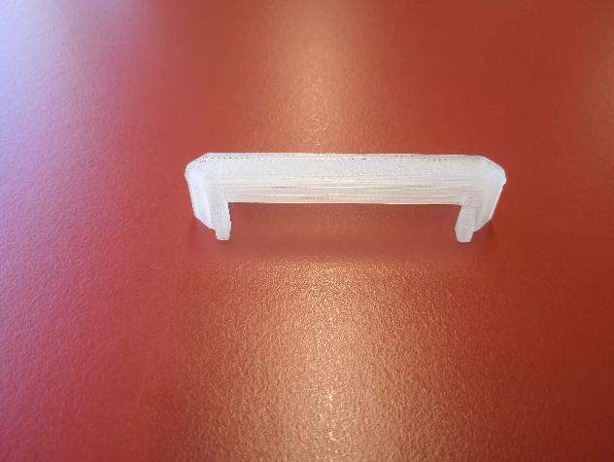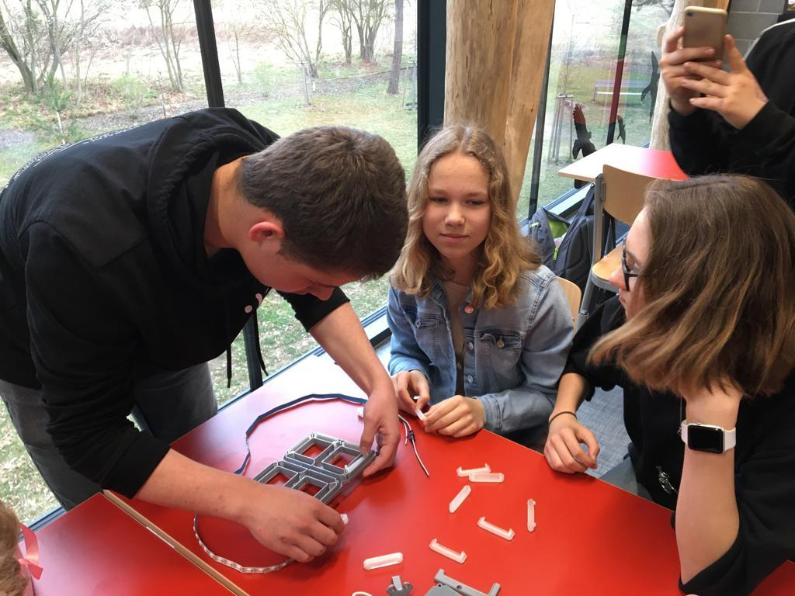

Before introducing and gluing the Led tape, it is important to check its functionality. It is also good to explain to the students how the individual parts of the tape light up. This will prevent incorrect assembly. During assembly, everyone can also use a file or sander at their own discretion and slightly adjust part of the clock structure to make it easier to close the clock.
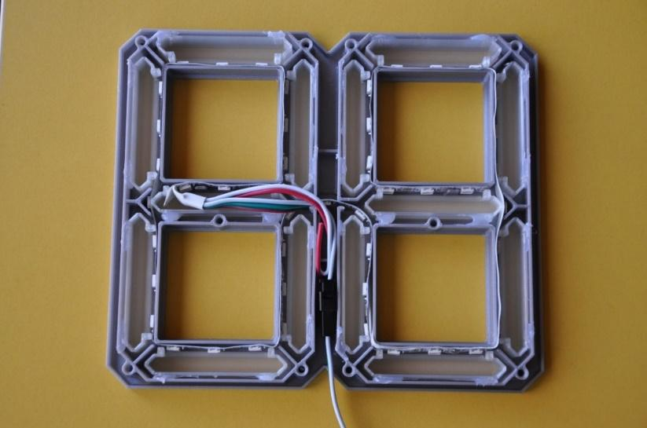

The wiring itself should not be difficult for electrical enthusiasts. However, it will take a while for lay people. We recommend writing down at least a few basic points about wiring, it will make the job easier.
Before soldering to the printed circuit board, it is necessary to test everything thoroughly and several times with the help of a non-soldering field.
The first time the device was powered up, the clock lit up in all possible colors, even though only red was programmed. This was fixed by tinkering with the potentiometer which is located directly on the power supply.
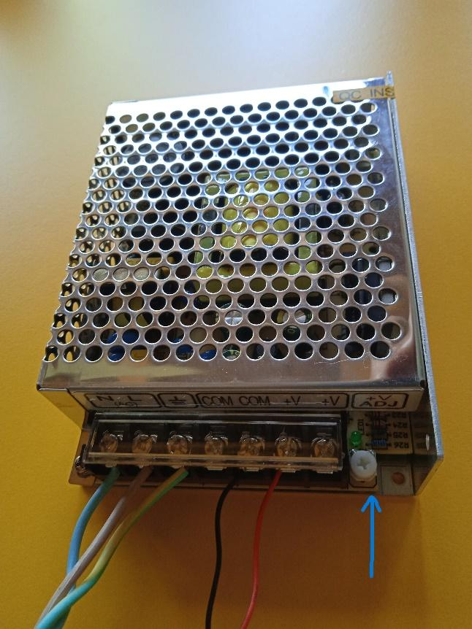
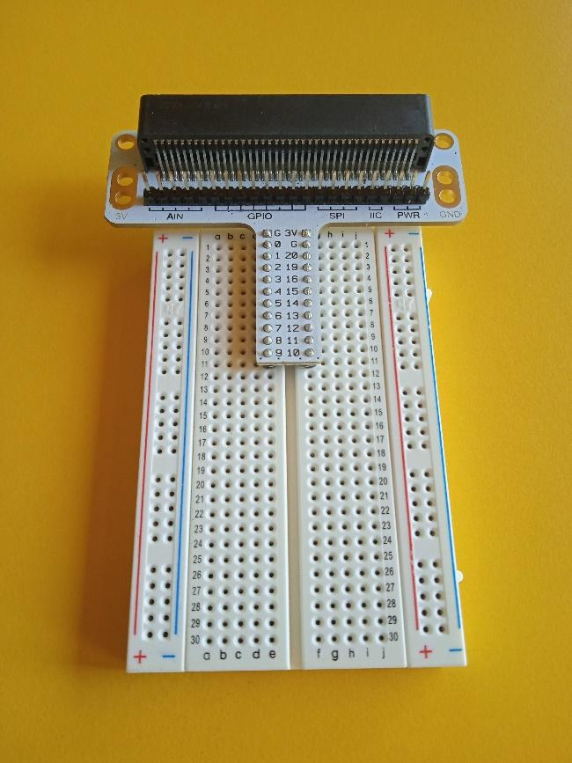
Non-soldering contact field Power supply with marked potentiometer

Assembly of the structure for the optical gate

When the clock was almost finished, there was still a problem with the attachment of the optical gate. Our project does not work like a classic digital stopwatch commonly used in physical education classes. We start them classically by pressing a button, but partial split times are recorded automatically by crossing the imaginary finish line. The way it works is that the laser shines continuously on the photoresistor and as soon as the light beam is interrupted (e.g. by a runner), the clock evaluates this interruption as a split time.
We therefore decided to 3D print small pads (see chapter 3D printing), into which the laser and photoresistor are attached with screws. Each of the mats is then attached to wooden stakes made by students in our school's workshops. The whole device will thus be able to be used practically anywhere, just hammer the optical gate into the ground and run.
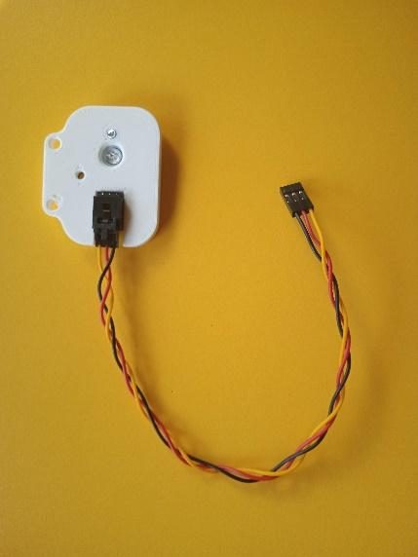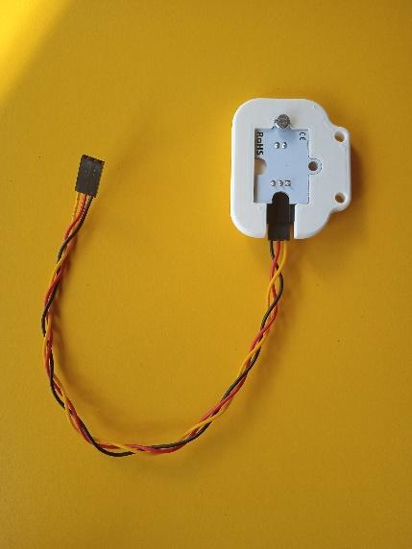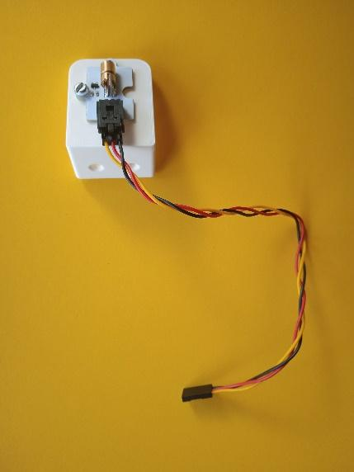
Pad for the sensor from the front Pad for the sensor from the back Pad for the laser
Manufacturing procedure of optical gate holders:
Based on the drawing, the students tried to make a technical drawing. Timber 100 cm long was purchased. Pupils worked in pairs. Each pair first sharpened the tip with a wood saw according to the drawing. A platform measuring 217 x 55 x 17 mm was placed at the top of each piece of wood using a dowel joint and Duvilax glue. A printed pad for part of the optical gate was attached to the platform with screws.
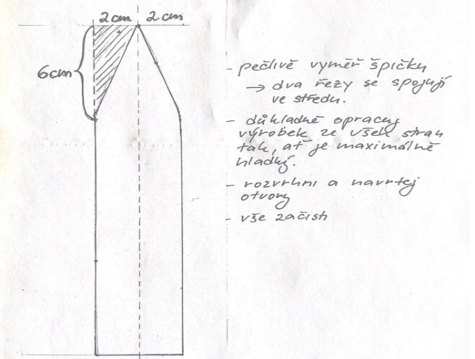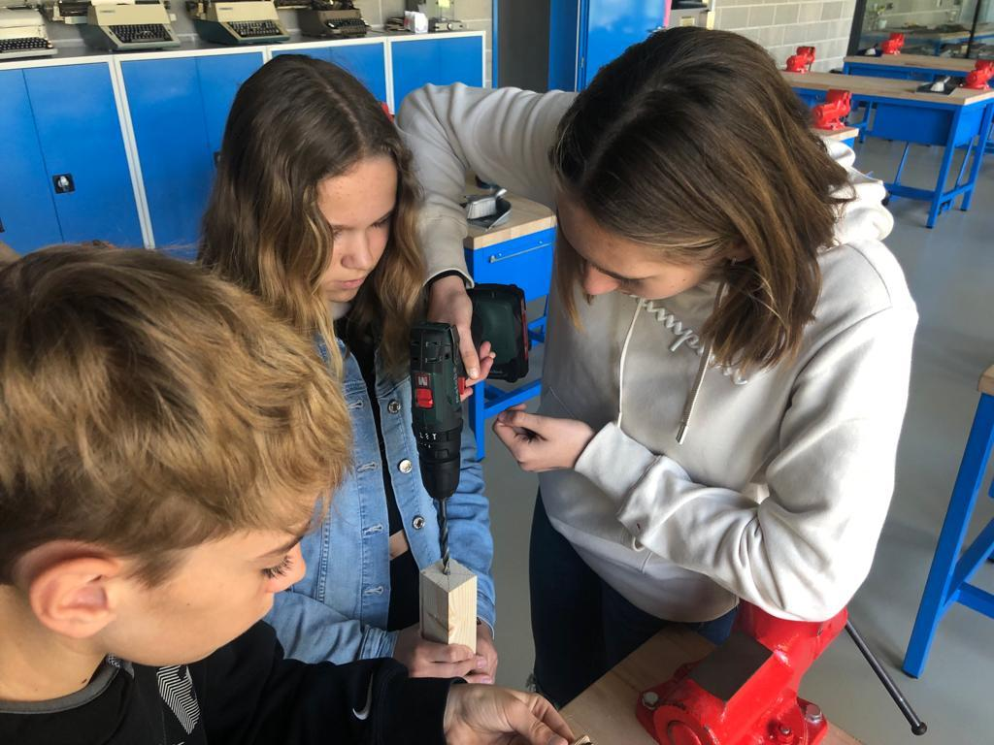
The most common errors and possible problems:
Caution when working with wood. Of course, the optical gate can be hung on almost anything, but we also made this possible thanks to the new workshops in our school and thanks to practicality.
It is important that the poles are high enough (up to the waist area) because split times may be recorded for each leg separately. One runner would thus record two times, which would be impractical and confusing. During the first attempts, we did not think of this possibility and the stakes had to be connected, when the lower part was again cut flat with a wood saw and then attached to a new tip with a length of 150 mm with a pin joint. Everything was still secured with Duvilax glue.

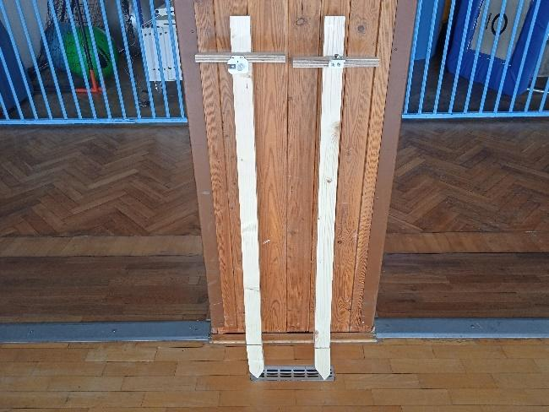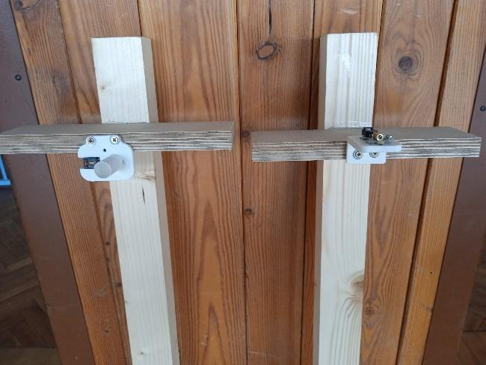

Heart rate measurement using a smart watch

A bit of theory

Since there will be statistics and graphs in the next few pages, it is important to briefly outline what they are about. Of all the data that can be measured with a smart watch, we have chosen only those related to heart rate, intensity zones and active calories for our project. A larger analysis would be appropriate for specialized athletes, and not for physical education classes, where the demands on performance are noticeably lower.

Heart beat

We will mainly evaluate the average heart rate. This means the number of beats per minute, or heart rate. An increased heart rate is the body's natural response to physical activity - our heart beats faster. Each physical activity can be performed with different intensity and each of you has different genetic predispositions for increasing the heart rate, more precisely, with the increasing difficulty of the physical activity, the heart rate may increase a little differently for each of us.

Heart rate zones

In most professional literature, it is stated that we distinguish five heart rate zones. These are determined with respect to the maximum heart rate, which can be approximated using the formula of 220 beats/min - the age of the individual.
Zone 1 (warm-up): 50 - 60% of maximum heart rate. In a shorter period of time (physical education class) we can talk about regenerative movement.
Zone 2 (fat burning): 60 - 70% of maximum heart rate. Exercise is good for fitness, but it is still more of a leisurely physical activity.
Zone 3 (aerobic zone): 70 - 80% of maximum heart rate. The zone of the aerobic threshold, at which the condition is already greatly improved.
Zone 4 (anaerobic zone): 80 - 90% of maximum heart rate. For many people, this phase is already unsustainable for a long time, but athletes like it bes
Zone 5 (extreme exercise): 90–100% of maximum heart rate. Anaerobic exercise that is mostly interval and time limited. By exercising in this zone, we move our condition the fastest.

Statistics

All ten pupils involved in the project took part in the measurement using smart watches. Two of the ninth graders had their own Apple Watches, so we decided to keep them. The rest of the pupils used watches earmarked for the Xiaomi Mi Watch project. At the beginning of each lesson, students set their watches to the appropriate activity. At the end of the lesson, they saved the activity and then the activity was recorded. The measured data from all pupils and from all physical education classes are not part of this methodology, but are attached to it as a file in the Microsoft Excel program.

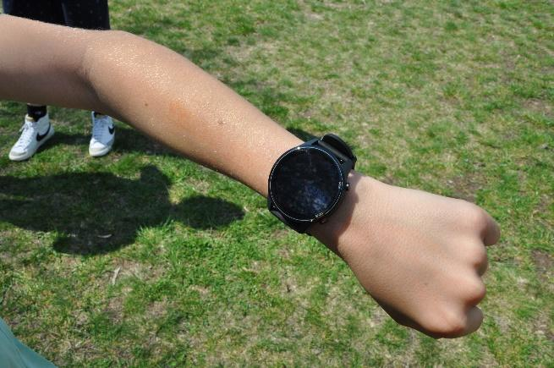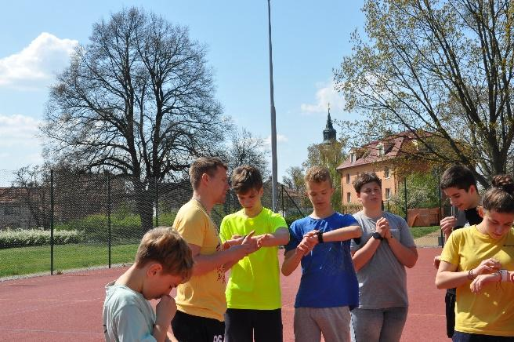
Everyone had a watch in a total of ten hours of physical education. The first eight hours were conceived as classic physical education classes, which the students and the teacher are used to at our school. The main content of these hours was sports in five cases: football, floorball, dodgeball, handball, tchoukball. In two cases physical fitness tests: Beep test (endurance test) and jump over the box and in one case improvement of movement skills in basketball. The goal of these lessons was to get an idea of ​​how the students react to classical physical education, as smart watches have not been used in school so far.
In the last two lessons, the students tried more intensive physical education (these lessons are shown separately in the graphs). During the first lesson, the Rowing Club Hodonín hit our mark, which recruited at our school with the help of trainers (skiing, rowing and cycling), and so the pupils also recorded this non-traditional lesson.

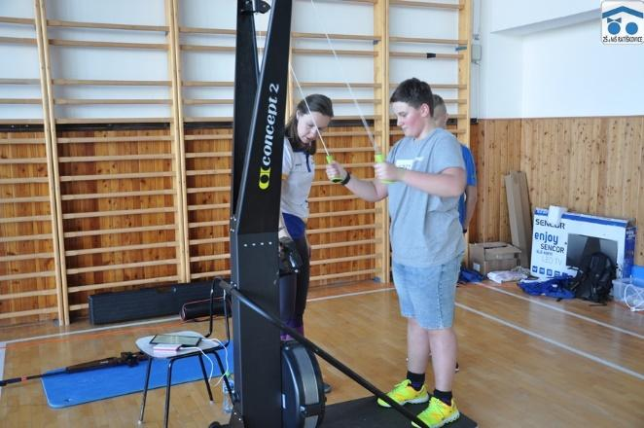
The last measured hour was essentially interval running training, which is regularly used in a number of sports during the period intended to increase fitness. In this lesson, the students ran a hundred-meter section in the form of a pyramid, where at first the hundreds were increased in one series and then decreased again after reaching the maximum number of four.
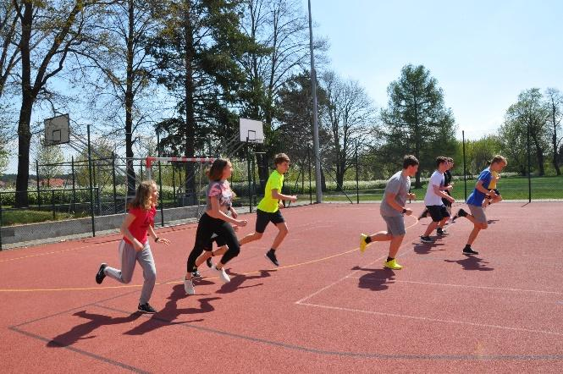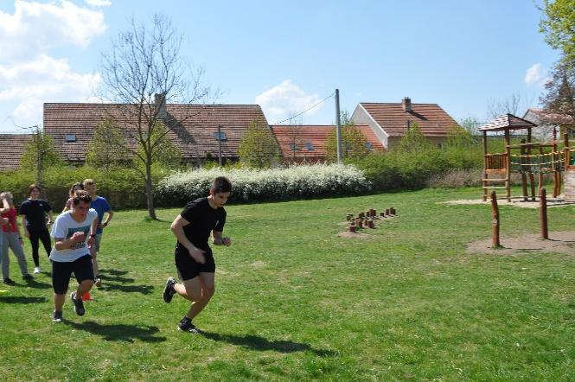

Heart beat

The first activity measured was the number of beats per minute. The most telling value in terms of the intensity of the physical education lesson was the average heart rate. In addition, for the sake of order, we also averaged the maximum heart rates recorded in the hours as well as the minimum heart rates. The average number of beats per minute endured a stricter measure during the last two hours of physical education, when its value reached a value of 135.3. The average value of all hours was much lower and just barely exceeded 120 beats per minute. The average maximum heart rate also turned out similarly. The average of the last two hours was almost 190 beats per minute, while the average of all hours was 175.58 beats per minute. The average of the minimum heart rates was almost identical for both monitored statistics, here it is probably due to the fact that each activity was started from complete rest, and therefore the minimum heart rate will in most cases be from the beginning of the lesson. Just for the sake of interest, the absolute maximum heart rate once reached the value of 197 beats per minute during the last interval exercise, and several times it reached the value of 196 for several students, and not only in the final two hours, but also during the endurance Beep test or during classical football. Two different students had their average heart rate drop below 100. Once it was 97 during the vault and the second time it was 99 during the shuttlecock. On the contrary, the students had the maximum average heart rate during the interval lesson of physical education - once 158 and the second time 156. The lowest measured heart rate was 52 during the lesson when football was played.

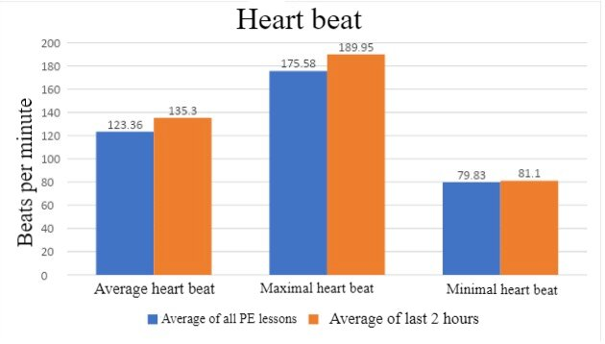

Heart rate zones
The most important and most telling indicator of the intensity of a physical education class and any sports activity in general is the movement in heart rate zones relative to the duration of exercise. The average duration of physical activity, in our case one hour of physical education, slightly exceeded 38 minutes, which we think is standard for a lesson with arrival and clothing change. From the graph below, you can see (rather unclearly) the stay in heart rate zones in all physical education classes. At first glance, however, it can be seen that the pupils got into the really demanding zones 4 and 5 at least or not even at all (of course, exceptions also apply here), and on the contrary, the stay in the more pleasant zones 1 and 2 prevails. the frequency reaches even below fifty percent of the maximum (i.e. below zone 1). This time from physical activity is then not evaluated - it can easily happen that the total activity time does not match the overall distribution of time spent in heart rate zones. In our project, we added the occasional missing minute to zone 1, which in the end will help the lesson a little, but again it will not be a complete stew. It is also necessary to take into account that the zones are calculated for guidance (although they will not differ much in the result). If everything were to be 100 % correct, every monitored pupil would have to pass a stress test before the measurement, where the zones would be identified and there would also be an individual recommendation where everyone should get their heart rate during the lesson.
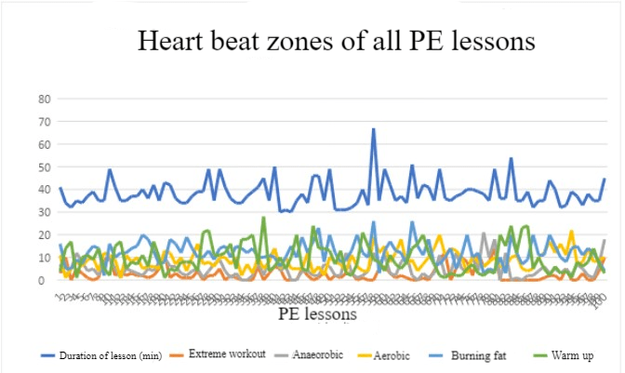
The following two graphs show the average stay in heart rate zones. First, everything is shown in minutes and then, for a better idea, in another graph in percentages.
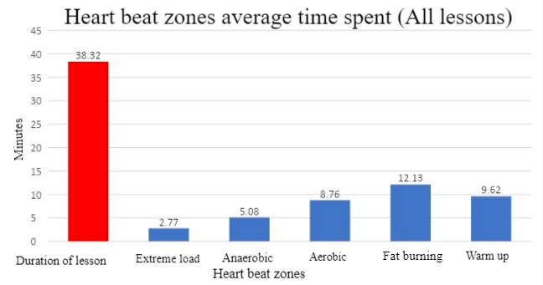

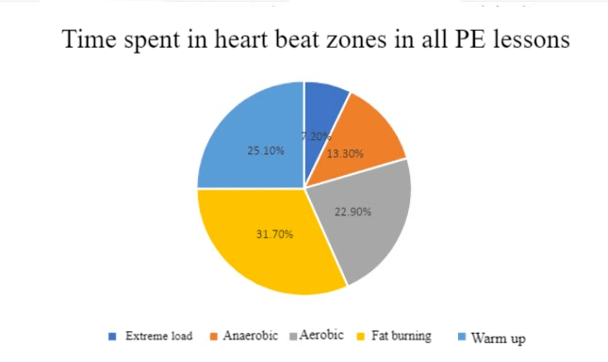
The last two heart rate zone graphs show the same thing as above, but this time only from the last two hours of PE. Here you can clearly see that the individual time spent in the zones has fairly evened out. The duration of the lesson itself stretched out slightly, when we finished, especially with interval training, when everything planned was completed.
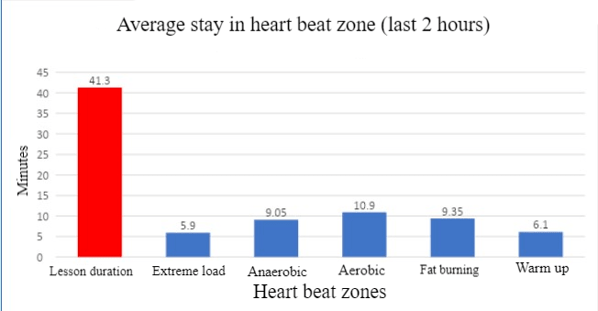
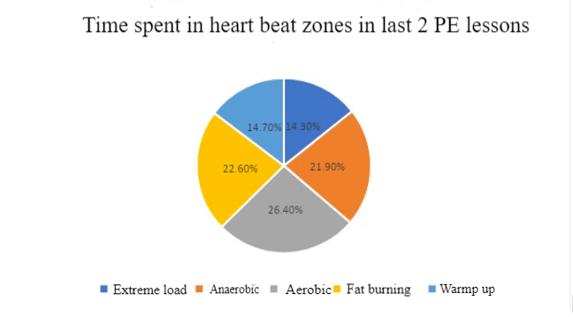

Active calories
The last data measured and recorded were active calories (kcal). By definition, these are calories burned during some physical, i.e. non-sedentary, activity. The watch calculates active calories based on the user's activity level, age, height, weight, gender and heart rate.
The most calories burned was 454 during the last, jogging, physical education class. Conversely, the lowest value of active calories was 91 during the hour when the skip was performed. It can be seen from the graph that the average of active calories was 215.86 during all hours of physical education. According to assumptions, during the last two hours the average increased to 307.2 active calories.

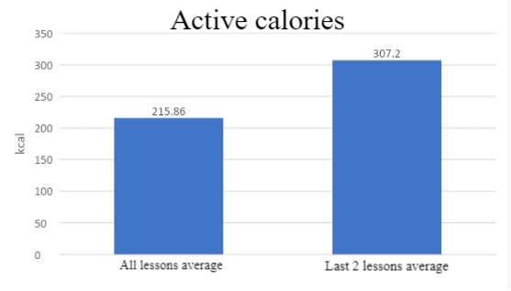

Evaluation

A partial goal of the project is to record the intensity of physical education classes with the help of smartwatches for a selected group of students. Using data collection through regular measurements and evaluations, also obtain information about the condition of these pupils and then try to increase the intensity of the lessons and the performance of the students.
When we focused on the sub-goal gradually, we recorded the intensity of the lessons of the pupils involved in the project. The total sample from which the data was recorded was basically one hundred hours (or at least the students did a hundred hours of physical education together). We think that this is a sufficient sample to get a certain picture of the condition of these pupils and, in general, to find out where we can push ourselves in physical education classes. It's probably not worth getting into some extreme analysis, which would far exceed the boundaries set for the project, but we can have a few comments on the graphs and subsequently on the possible improvement of the intensity of the hours.
The most important indicator (as was written above) is staying in heart rate zones. It is clearly visible here that if we did not proceed with a trial and targeted an increase in intensity in the last two hours of physical education, the pupils would be moving mostly in comfortable zones. From the graphs above, it can be seen that in zone 1 (which is essentially a regeneration zone) and in which pupils spend an average of exactly a quarter of the class hour. Pupils then spend almost 32 % of the lesson in zone 2, which is moderate movement that can lead to fat burning over a continuous longer period of time (however, this does not happen in physical education - there are usually a lot of pupils in the class and if, for example, there is a game sport, it alternates, so zones 3 and higher are more likely to alternate with complete rest). 23 % of the time, the students perform an activity on the border of the aerobic threshold, and only now is it possible to talk about some development of fitness. Only 13 % of the total time of the lesson (an average of five minutes) the students reach zone 4, which is already really uncomfortable and they reach the limit of the anaerobic threshold. Some do not reach zone 5 (extreme load) at all, and on average 7 % (not even three minutes) is spent in it. Attention! It should be added that the values ​​are pushed up by the penultimate and last lesson (exercise machines and interval training), when the pupils purposefully practiced more than is normally common in physical education.
From the text in the previous paragraph, it is clear that physical education does not serve much as a means of increasing fitness, but rather for regular exercise and as a possible supplement to one's own extracurricular activities. Of course, the intensity of the lessons could be increased (similar to our two lessons), but the question is whether it would be manageable for the students and whether it would not turn into endless excuses in physical education lessons and the like. It is clear from our data that the intensity of the lessons can be slightly increased and that is what we can focus on in the future - for example, the mandatory introduction of dynamic warm-up, the addition of more preparatory games and the like. There are, however, extracurricular physical activities for some bigger training sessions. Perhaps it would be worth considering to allow pupils at least this kind of regular movement to a greater extent and with greater regularity by increasing the weekly subsidy from two hours of physical education per week to at least three, as is common in some other states. Then it would be possible to work better with everything, even thanks to that regularity.
We will start working on a slight increase in the intensity of the hours in the body clock classes almost immediately, it is necessary these days. Using a watch should make things easier. A good impulse for us was that even students who are not involved in the project wanted to measure their heart rate during the lesson and were simply interested.

The most common errors and possible problems:

While it may seem like working with a smartwatch is commonplace these days, it's not. At least half of the pupils fumbled a lot when handling them at the beginning and it was necessary, in order to save time, to train them briefly.
In the same way, it was necessary to explain to the students involved in the project how the body actually reacts to stress. To outline to them all the theory one should have an idea of ​​if one aims to use a smartwatch for any sensible purpose. A light excerpt from this topic might not be a bad idea even in regular physical education classes, because while active athletes have at least some subconscious awareness of heart rate, the average layman certainly does not.
User knowledge of the Microsoft Excel program is also not harmful for pupils, and we teachers were also happy to repeat it.
As the last hour of an intensive PE class, we chose interval training, which demonstrated that it is possible to get the heart rate moving where it is needed to increase fitness. However, it is necessary to realize that having such physical exercise would not mean developing a desire for movement for students who do not do sports, but quite the opposite. Doing such physical activity once in a while is also probably not very suitable, as regularity is necessary to achieve the desired effect. Despite the fact that the regeneration time for students who are not used to more extreme loads is several days, which we also observed.
In the "post-covid" era, it is probably necessary to increase the intensity of physical education classes only with light intentions (if at all). Pupils' physical fitness is constantly deteriorating, and overexertion can easily lead to them looking for excuses so they don't have to exercise.

Conclusion

When evaluating and summarizing the project, we will no longer focus on the sub-goal, i.e. measuring the intensity of physical education lessons. Everything important was already written about this topic in the evaluation chapter. Let's go straight to the primary goal – the production of digital stopwatches.
First, we printed the individual components of the digital clock, as the time spent on the project progressed, other components important for the correct operation of the clock were printed. Looking back on the whole project, we're glad we made the job easier by getting help with the basic clock construction at www.thingiverse.com. Of course, small adjustments were made and over time we discovered other necessary things to print, which could be directly implemented by us, but the program part took so much time that if the design of the entire classes from scratch was still to be implemented, it is quite possible that we would not have , what to present.
Working in the development environment of Microbits was challenging for everyone involved. We cannot imagine that the students would prepare this or a similar topic entirely by themselves (this means students at a non-specialized elementary school). For a while, the plan also featured the possibility of controlling the entire device by remote control. However, we rejected this option and all control remained on the buttons of the Mikrobit.
We are glad that the school workshops could also be used and the structure for the optical gate was formed as part of the work activities. There are countless ways to deal with the given problem (anchoring and positioning), we decided this way and we can't complain. It also took some time to assemble and connect all the parts together, and it didn't always work right away. The question is how to deal with the amount of wires and connecting wires that are part of the entire device. 3D printing of a larger box for a power supply, a printed circuit board and a microbit with a power bank is offered. However, the wires to the optical gate cannot be reasonably covered.

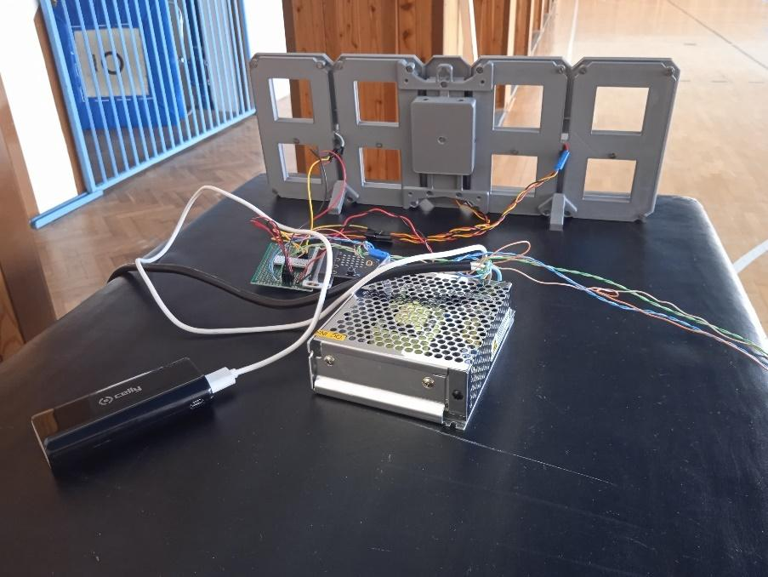
It is still necessary to comment on the practicality of the entire lessons as part of the use in physical education lessons. We simply say that they are impractical. We'll explain why. It is a relatively large device containing not only the clock itself, but also a power supply connected to it with a microbit connected to a power bank (this is used so that e.g. a laptop does not have to be dragged around to connect to the USB – we cut the USB cord hard and connect it to the power supply they didn't want to because of frequent corrections in the program). If we wanted to use the device in the field, where it is most needed, we would still have to carry an extension socket. If the device would only work in such a way that the times would be read off by the human eye directly after the student has run to the finish line, it could still be considered suitable for regular physical education. Then, of course, there's the optical gateway, which adds extra components and extra wires. In addition, the laser works differently and takes breaks in the gym, in a dark room or in the sun. The disadvantage is also that the sensor on which the laser beam falls is small, and the correct anchoring of the optical gate is a difficult process in itself. So it's all about setting up, and since any physical education teacher can take his pocket stopwatch and have everything else out of the way, the use of lessons in this form is unimaginable. With the usual use in physical education classes, it is therefore in doubt, but as part of a sports day, inter-class or even inter-school activity, the classes are an ideal opportunity to stand out. At such an event, it would be nice to show off what was created in our school, our teachers and students. Moreover, as a project it is beneficial for all involved and the result (at least visually and functionally) is worth it.
When we sat in the first workshops at the beginning of the project as complete beginners, we didn't really believe that we would make it to a successful end, but we did. The clock counts correctly, the split times are recorded and after the stopwatch has stopped, the split times are shown on the display. With the increasing number of computer science classes, another project using a 3D printer and microbits (albeit probably a little lighter) will certainly follow at our school.
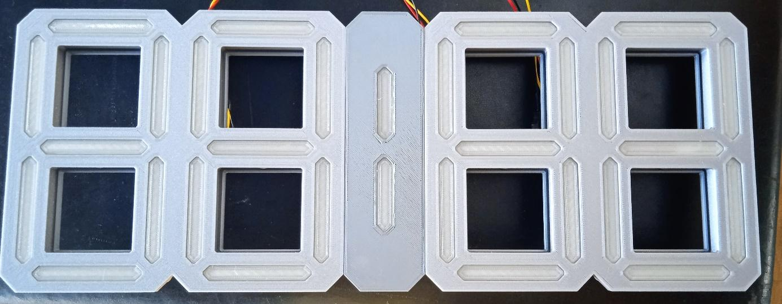
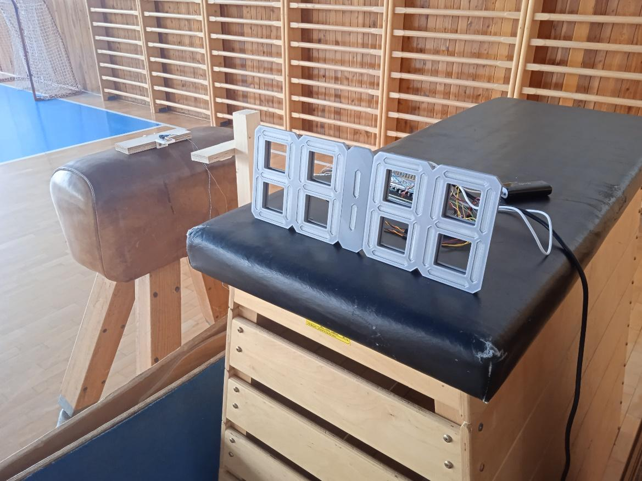

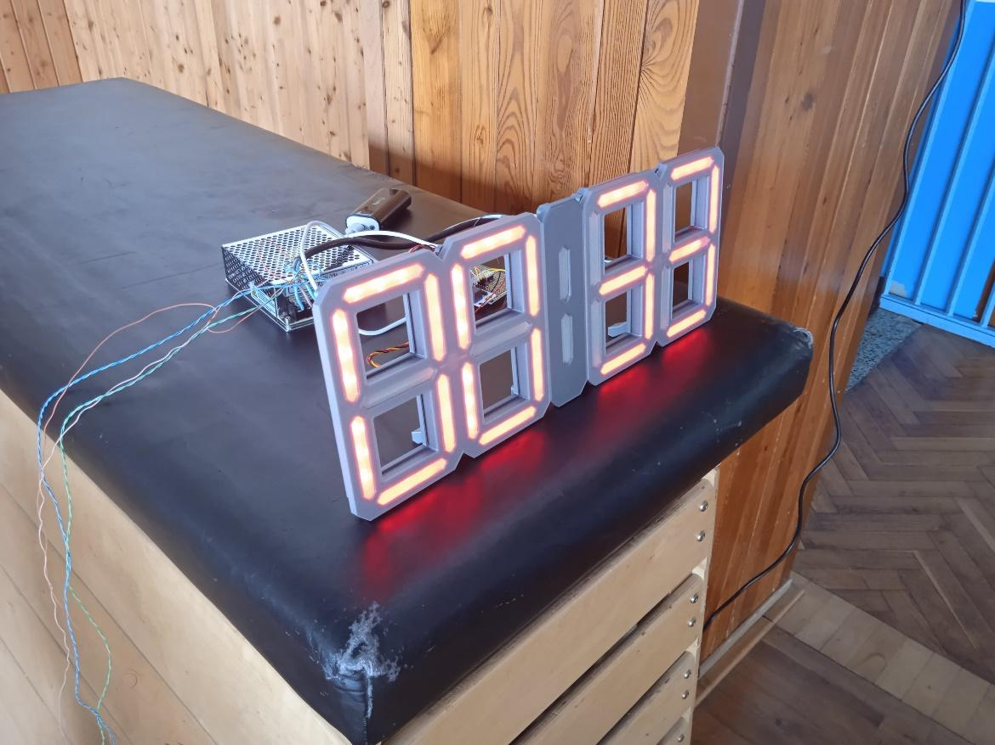

List of links

- E-shops for the purchase of equipment and components
www.alza.cz
www.shop.prusa3d.com
www.hwkitchen.cz
www.gme.cz
www.tme.eu
www.pajenicko.cz
www.t-led.cz
www.czc.cz

- Programming in the MakeCode environment
https://makecode.microbit.org

- SHeart rate and heart rate zones
www.tovys.cz/clanky/vse-o-hodinkach/zony-srdecniho-tepu.html + Garmin Connect application

- Calorie
www.support.garmin.com/cs-CZ/
https://support.garmin.com/cs-CZ/?faq=lkl4cwCLlK7ox362uGQEV7

- 3D objects and clock constructions
www.thingiverse.com

- Creating 3D digital designs using an online CAD environment
www.tinkercad.com

- Program PrusaSlicer
www.prusa3d.com/cs/stranka/prusaslicer_424/

